Domain 2: Incident Response, Business Continuity and Disaster Recovery Concepts
Here are the primary things to remember in this domain:
- The Incident Response plan responds to unexpected changes in operating conditions to keep the business operating.
- The Business Continuity plan enables the business to continue operating throughout the crisis.
- If both the Incident Response and Business Continuity plans fail, the Disaster Recovery plan is activated to help the business return to normal operations as quickly as possible.
TYPES OF INCIDENT:
- Breach → The loss of control and unauthorized acquisition
- Event → Any observable occurrence in a network
- Exploit → An attack that exploit system vulnerabilities
- Incident → An event that jeopardizes the confidentiality, integrity,or availability of an information system
- Intrusion → an intruder gains access to a system or system resource without authorization
- Threat → Any event with an adversely impact on organizational operation, assets and individuals through an unauthorized access, destruction, disclosure or DoS
- Vulnerability → Weakness in an IT or implementation that could be exploited by a threat source
- Zero Days → New discovered system vulnerability with the potential of exploitation without risk of detection
A red book is a hard copy backup accessible from outside the building
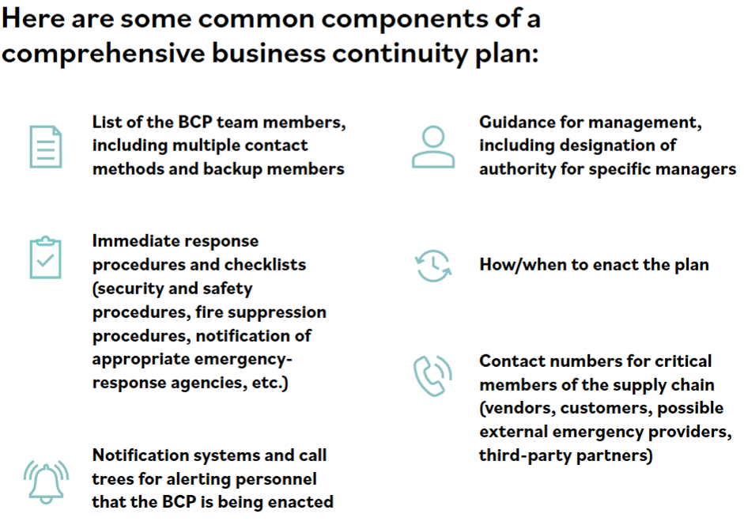
Business Continuity Plan is the proactive development of procedures to restore business operations

Domain 3: Access Control Concept
Access is based on Three fundamental concepts:
- Subject → A subject is the initiator of a request for service; therefore, a subject is referred to as “active.”
- Object → Anything that provides service to a user, It’s passive (responds to a request) May have a classification.
- Rules → A rule compare multiple attributes to determine appropriate access and define how much access is allowed. An example is a firewall access control list, a rule validates the level of access when a user (subject) attempts to access a file (object).
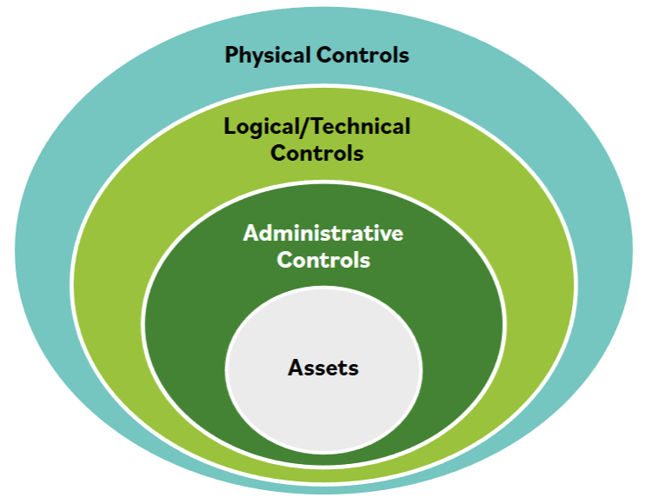
Defense in depth describes an information security strategy that integrates people, technology and operations capabilities to establish variable barriers across multiple layers of the organization (Layered defense strategy).

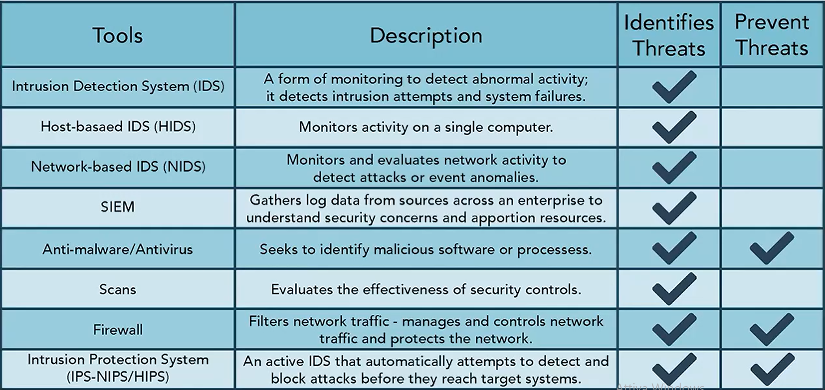
Demilitarized Zone → What term describes a portion of the organization's network that interfaces directly with the outside world and typically has more security controls and restrictions compared to the rest of the internal IT environment?

